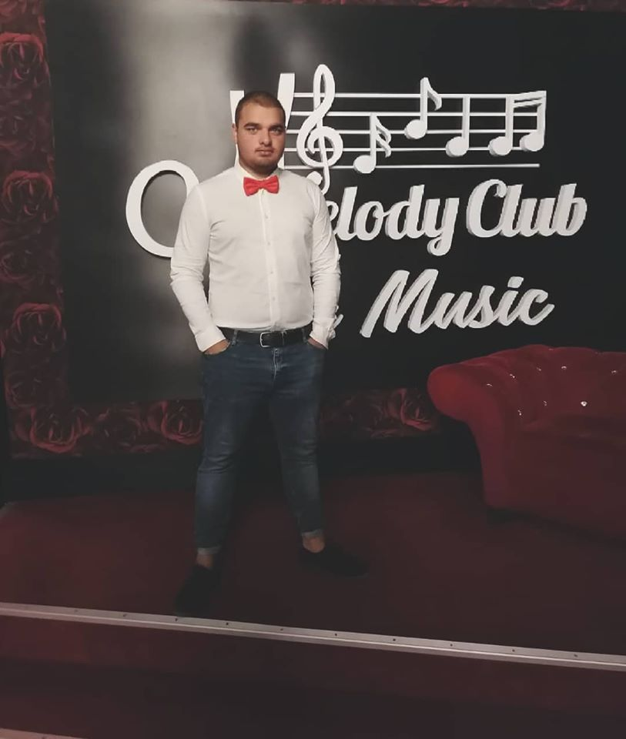
CANDIDATE PROFILE Photo

Position: Waiter
Accepts different/lower position offers : Bartender, Helper in Bar
Name / Surname : Vioreanu Stefan-Auras
Date of birth: 10.01.2000
Address: Strada Garii nr.33, Ianca, Braila, Romania
Telephone: 0040760373100
E-mail: vioreanul@yahoo.com
Nationality: Romanian
Skype(social):

Education

Period | 2015-2019
Educational Institution | Liceul Teoretic “Panait Cerna” Braila, Dorobantilor 311
Degree | Assistant Programmer

Professional Experience

Period | 06.2015-10.2015
Employer | Heaven’s (restaurant)
Position | Waiter
Special Duties & Responsibilities

Period | 9.2018-5-2019
Employer | Melody Club Braila
Position | Waiter
Special Duties & Responsibilities

Period | 6.2018-9-2019
Employer | Max Club Costinesti
Position | Waiter
Special Duties & Responsibilities

Language Skills / level (beginner, medium, advanced)
- Romanian: Native
- English: Medium
- Spanish: None

References and Diplomas: Bacalaureat diploma, Assistant Programmer diploma.

Availability: 10.10.2019

Salary Expectations: As per offer



Consent to Use Job Application Data (GDPR)

As part of any recruitment process, our organization collects and processes personal data relating to job applicants. The company is committed to being transparent about how it collects and uses that data and to meeting its data protection obligations as per GDPR regulation. This Statement aims at informing you of how our organization is going to use the information you submit when applying for a job.
Data will be stored in a range of different secured places, including on your application record, in HR management systems and on other IT systems (including email).
We need to process data to take steps at your request prior the employers to entering into a contract with you. We may also need to process your data for the employers to enter into a contract with you. In some cases, we need to process data to ensure that we are complying with its legal obligations.
Our organization has a legitimate interest in processing personal data during the recruitment process and for keeping records of the process. Processing data from job applicants allows us to manage the recruitment process, assess and confirm a candidate's suitability for employment and decide to whom to offer a job.
If your application is unsuccessful, our organization may keep your personal data on file in case there are future employment opportunities for which you may be suited. We will ask for your consent before we keep your data for this purpose and you are free to withdraw your consent at any time. If your application for employment is successful, personal data gathered during the recruitment process will be transferred to your Employer and retained during your employment.
Providing your Job Application data is voluntary. However, if you choose not to provide all of the data that is requested for your application, our ability to consider you as a candidate may be limited.
The Job Application data you provide will be used to assess your application for employment, to verify your information and conduct reference checks, and to communicate with you and inform you of further career opportunities. If employment you accept employment with our clients, the information collected will become part of your employment record and will be used for employment purposes.
By submitting your Job Application data you are granting your consent to the processing of that information, including to the transfer of your Job Application data in accordance with this Statement.

For other information or enquiries, you can contact us at office@aurasjobs.ro or 0040725085231 / 0040730719323

